M-BOTS: RECONFIGURABLE
MODULAR ROBOTS

A project report
Submitted by

ADARSH K SUDARSHAN
ANGEL MARIYA VARGHESE
MINNU MATHUKUTTY
VISHNU SANTHOSH

In partial fulfillment for the award of the Degree of

BACHELOR OF TECHNOLOGY
IN
ELECTRONICS & COMMUNICATION ENGINEERING



DEPARTMENT OF ELECTRONICS &COMMUNICATION
ENGINEERING

Mar Athanasius College of Engineering

Kothamangalam, KERALA,INDIA 686666

Affiliated to

APJ Abdul Kalam Technological University
Trivandram, Kerala, india
June 2019

DEPARTMENT OF ELECTRONICS AND COMMUNICATION ENGINEERING
MAR ATHANASIUS COLLEGE OF ENGINEERING KOTHAMANGALAM



CERTIFICATE

This is to certify that the project report entitled
M-BOTS: RECONFIGURABLE
MODULAR ROBOTS

Submitted by Mr. Adarsh K Sudarsan, Ms. Angel Mariya Varghese, Ms. Minnu Mathukutty, Mr . Vishnu Santhosh towards partial fulfillment of the requirements for the award of Degree of Bachelor of technology in Electronics and Communication Engineering is a bonafide record of the work carried out by them under our supervision and guidance.

Prof. Athira Prasad Prof. Athira Prasad Prof. Babu P Kuriakose
Name of Project Guide Name of Project Head of the
Coordinator Department

Place:
Date: (Office Seal)
Font:-Times New Roman Size :- 12
Italics Letters

ACKNOWLEDGEMENT
It is a great pleasure to acknowledge all those who have assisted and supported me for successfully completing my project.
First and foremost, I sincerely thank the ‘God Almighty’ for his grace for the successful and timely completion of the project.
I take this opportunity to extend my sincere thanks to my guide and Project coordinator Athira Prasad, Assistant Professor, Department of Electronics & Communication Engineering for her constant support and immense contribution for the success of my project.
I am also grateful to Prof. Babu P Kuriakose, Head of Electronics & Communication Engineering Department, for the valuable guidance as well as timely advice which helped me a lot during the preparation of the project. I also thank all other members of Department of Electronics &Communication Engineering for sharing their valuable comments during the preparation of the project.
I am deeply indebted to Dr. Mathew K , Principal, Mar Athanasius College of Engineering for her encouragement and support.
Finally, I would like to acknowledge the heartfelt efforts, comments, criticisms, co-operation and tremendous support given to me by my dear friends during the preparation of the project and also during the presentation without whose support this work would have been all the more difficult to accomplish.

ABSTRACT
In most natural disasters like hurricanes, earthquakes, fires there are situations where people get trapped. There comes the need of search and rescue operation teams. In most situations they are carried out by humans, needing a lot of specialized manpower and hours of work .As a solution for this, robots are introduced into the field. Mbots are robotic modules with simple structure. They have a self reconfigurable design which is composed of homogeneous and heterogeneous modules and have an ability to configure their shapes and repair them by changing the connection between the modules. Our single module consist of a male and female part connected through a link between them which make them versatile and flexible to work on all terrain search and rescue operations using bio-inspired locomotion mechanisms. The Mbots system can change its 3-D structure and its motion in order to adapt to the environment. Possible applications of the Mbots are autonomous exploration under unknown environment such as planetary explorations, or search and rescue operation in disaster areas.

CONTENTS
CHAPTER 1 9
INTRODUCTION 9
CHAPTER 2 xiii
LITERATURE SURVEY xiii
CHAPTER 3 xvi
OVERVIEW OF THE DESIGN xvi
3.1 HOW IT WORKS? xvi
3.1.UNIQUE DESIGN xviii
CHAPTER 3 xix
SOFTWARE IMPLEMENTATION xix
4.1.FUSION 360 xix
4.2.VREP xxiii
CHAPTER 5 xxvii
HARDWARE IMPLEMENTATION xxvii
5.1.SCHEMATICS AND COMPONENTS xxviii
5.1.1.Atmega 328P xxix
5.1.2.NRF24L01 xxx
5.1.3.HC-05 Bluetooth module xxxi
Hardware Features xxxi
Software Features xxxi
5.1.4.LM 317 xxxii
5.1.5. Servomotors xxxiii
CHAPTER 6 xxxv
ASSEMBLING OF PARTS xxxv
CHAPTER 7 li
CONCLUSION AND FUTURESCOPE li
REFERENCE lii

LIST OF FIGURES
Figur 3.1: Transformation of modules………………………………7
Figure 3.2 : MBOTS module………………………………………....8
Figure 4.1:Part 001……………………………………………………………9
Figure 4.2:Part 003………………………………………………….. 9
Figure 4.3:Part 002………………………………………………………..10
Figure 4.4:Part 004…………………………………………………….10
Figure 4.5:Part 005………………………………………………………….10
Figure 4.6:Part 006…………………………………………………………..10
Figure 4.7:Part 007……………………………………………………………..10
Figure 4.8:Part 008…………………………………………………………..10
Figure 4.9:Part 009 …………………………………………………………….11
Figure 4.10:Part 010……………………………………………………………11
Figure 4.11:Part 011…………………………………………………………11
Figure 4.12:Part 012…………………………………………………………11
Figure 4.13:Part 013…………………………………………………………11
Figure 4.14:Part 014…………………………………………………………11
Figure 4.15:Snake motion…………………………………………………….13
v
Figure 4.16:Hexapod Motion………………………………………………….13
Figure 4.17:Quadrupted Motion……………………………………………….14
Figure 5.1:Schematic diagram………………………………………………….16
Figure 5.2: Pin diagram of ATMEGA328P…………………………………...17
Figure 5.3:NRF24L01………………………………………………………18
Figure 5.4:LM317 ………………………………………………………….20
Figure 5.5:servomotor……………………………………………………….21
Figure 6.1:Step 1………………………………………………………………..22
Figure 6.2:Step 2………………………………………………………………23
Figure 6.3:Step 3…………………………………………………………………24
Figure 6.4:Step 4…………………………………………………………………25
Figure 6.5:Step 5……………………………………………………………26
Figure 6.6:Step6A……………………………………………………… 27
Figure 6.6:Step 6B……………………………………………………………27
Figure 6.7:Step 8……………………………………………………………28
Figure 6.8:Step 9……………………………………………………………29
Figure 6.9:Step 10………………………………………………………… 30
Figure 6.10:Step 11……………………………………………………….30
Figure 6.11:Step 12…………………………………………………………31
Figure 6.12:Step 13………………………………………………….32
vi
Figure 6.13:Step 14…………………………………………………………33
Figure 6.14:Step 15……………………………………………………………34
Figure 6.15:Step 17………………………………………………………….. 35
Figure 6.16:Step 18…………………………………………………………36
Figure 6.17:Step 18……………………………………………………….36
Figure 6.18:Step 19A………………………………………………………….37
Figure 6.19:Step 19B……

CHAPTER 1

INTRODUCTION

In most natural disaster situations, like hurricanes, earthquakes, fires, there are situations where people get trapped without the possibility to get out to safety by themselves. Then is when search and rescue operation teams come at play. Nowadays, most of the search and rescue operations are carried out by humans, needing a lot of specialized manpower and hours of work to look for possible survivors. Unfortunately disasters caused by earthquakes, floods, tsunamis or hurricanes are very often in the news. In these scenarios the priority is to find survivals quickly, otherwise they will die. In urban disasters the environment is extremely unstructured, chaotic and full of pieces of rubble everywhere . This makes very difficult and dangerous for the USAR (Urban Search And Rescue) teams to move and locate people. Besides, it is clear that if a building has collapsed, there will be likely people inside that should be rescued as soon as possible. During the last decade, researchers around the world have been facing the problem of designing tele-operated robots capable of moving in such environments and to assist the USAR teams. Properties such as versatility, adaptability and flexibility are taken into account when designing these robots. Miller suggested snakes robots (consisting of yaw modules with passive wheels) as good candidates for moving in unstructured terrains, in a similar manner than real snakes do. A camera located at the end of the trunk was used for inspecting unreachable areas such as small cracks and pipes. Modular robots with a 1D topology can be divided into two groups: serpentine and snake robots. The former use active tracks or wheels for self-propulsion while the latter use body motions in a similar manner than their biological counterparts.
The word robot can be referred to as both physical robots and virtual software agents, but the latter are usually referred to as bots. There is no consensus on which machines qualify as robots but there is general agreement among experts
and the public that robots tend to possess some or all of the following abilities and functions: accept electronic programming, process data or physical perceptions electronically, operate autonomously to some degree, move around ,operate physical parts of itself or physical processes, sense and manipulate their environment and exhibit intelligent behavior especially behavior that mimics humans or other animals. “You must be shapeless, formless, like water. When you pour water in a cup, it becomes the cup. When you pour water in a bottle, it becomes the bottle. When you pour water in a teapot, it becomes the teapot. Become like water my friend.” Bruce Lee. The Mbot is a modular transformable robot designed to be versatile, flexible and self-reconfigurable. The idea of modular robots is that they can adopt any shape they want, by changing the position and the connection of their modules. The small size, the versatility and the limitless shapes it can adopt, make Mbots the perfect robot for all kind of search and rescue operations.
Modular robots are a new breed of robots that are designed to increase the utilization of robots by modularizing their architecture. The functionality and effectiveness of a modular robot is easier to increase compared to conventional robots. These robots are composed of a single type of identical, several different identical module types, or similarly shaped modules, which vary in size. Their architectural structure allows hyper-redundancy for modular robots, as they can be designed with more than 8 degrees of freedom (DOF). Creating the programming, inverse kinematics and dynamics for modular robots is more complex than with traditional robots. Modular robots may be composed of L-shaped modules, cubic modules, and U and H-shaped modules. ANAT technology, an early modular robotic technology patented by Robotics Design Inc., allows the creation of modular robots from U and H shaped modules that connect in a chain, and are used to form heterogeneous and homogenous modular robot systems. These "ANAT robots" can be designed with "n" DOF as each module is a complete motorized robotic system that folds relatively to the modules connected before and after it in its chain, and therefore a single module allows one degree of freedom. The more modules that are connected to one another, the more degrees of freedom it will have. L-shaped modules can also be designed in a chain, and must become increasingly smaller as the size of the chain increases, as payloads attached to the end of the chain place a greater strain on modules that are further from the base. ANAT H-shaped modules do not suffer from this problem, as their design allows a modular robot to distribute pressure and impacts evenly amongst other attached modules, and therefore payload-carrying capacity does not decrease as the length of the arm increases. Modular robots can be manually or self-reconfigured to form a different robot, that may perform different applications. Because modular robots of the same architecture type are composed of modules that compose different modular robots, a snake-arm robot can combine with another to form a dual or quadra-arm robot, or can split into several mobile robots, and mobile robots can split into multiple smaller ones, or combine with others into a larger or different one. This allows a single modular robot the ability to be fully specialized in a single task, as well as the capacity to be specialized to perform multiple different tasks. Modular robotic technology is currently being applied in hybrid transportation, industrial automation, duct cleaning and handling. Many research centres and universities have also studied this technology, and have developed prototypes.

CHAPTER 2

LITERATURE SURVEY

“You must be shapeless, formless, like water. When you pour water in a cup, it becomes the cup. When you pour water in a bottle, it becomes the bottle. When you pour water in a teapot, it becomes the teapot. Become like water my friend.” Bruce Lee
The Mbot is a modular transformable robot designed to be versatile, flexible and self-reconfigurable. The idea of modular robots is that they can adopt any shape they want, by changing the position and the connection of their modules. The small size, the versatility and the limitless shapes it can adopt, make Mbot the perfect robot for all kind of search and rescue operations.In most natural disaster situations, like hurricanes, earthquakes, fires, there are situations where people get trapped without the possibility to get out to safety by themselves. Then is when search and rescue operation teams come at play. Nowadays, most of the search and rescue operations are carried out by humans, needing a lot of specialized manpower and hours of work to look for possible survivors.
After working at Ground Zero on the WTC, Dr. Robin Murphy, Professor of Computer Science at University of South Florida, who was working with search and rescue robots, said:“Robots proved helpful” ; “Using robots can minimize the number of personnel on site, and reduce the fatigue and errors” ; She sees mobile robots as scouts able to navigate, adapt and perceive. ; ”Robots will be manpackable” ; “so small that they can fit into small subhuman confines, able to tell their orientation as they snake through open spaces in rubble” ; “...going where no human should go”. In robotics, the usual approach for designing exploration robots is: First, study the terrain characteristics and then, designing a robot according to those needs. When moving through an unexplored and unpredictable terrain like an earthquake affected building, you never know which kind of obstacles will you find. There is where modular robots can do really well. The Mbot Modular Robot has been designed with adaptability in mind. Inspired by how fire ants colonies work, a number of modules (or small robots) find each other, connect mechanically and collaborate to act as one only robot, creating a collective intelligence. They can link together and build structures without any central command. The advantage of being all modules the same is that, if one of them breaks, it can easily get replaced by another one, creating a self-healing structure.By changing its configuration, the Mbot can move like a snake through a small pipeline, then transform into a wheel-like robot to move faster, then transform to a centipede robot when there is no vertical space and finally build a bridge to get to the other side of the hanging floor. While looking for the minimum size, the robot is designed to contain almost all the electronics and motors in one half, so that there is a large free space in the other half.That free space can be used to install a thermal camera, microphone and speakers, multiple sensors, more actuators (like grippers) or even more batteries.
This robot is Inspired by the MTRAN III, by The National Institute of Advanced Industrial Science and Technology (AIST), Japan. The M-TRAN system can change its 3-D structure and its motion in order to adapt itself to the environment. In small sized configuration, it walks in a form of legged robot, then metamorphoses into a snake-like robot to enter narrow spaces. A large structure can gradually change its configuration to make a flow-like motion, climb a step by transporting modules one by one, and produce a tower structure to look down. It can also generate multiple walkers. Possible applications of the M-TRAN are autonomous exploration under unknown environment such as planetary explorations, or search and rescue operation in disaster areas. The design of M-TRAN has the advantages of both two types of modular robots, lattice type and chain (linear) type. This hybrid design, unique 3-D shape of the block parts, and parallel joint axes are all keys to realize a flexible self-reconfigurable robotic system.An M-TRAN module is composed of two blocks (1/2 cubic & 1/2 cylindrical) and a link . Each of the three flat surfaces of each block can mechanically connect and couple with a surface of another module. All the connection surfaces have their gender and an active (male) surface can couple with a passive (female) surface in four possible relative orientations. The connection is controlled by the module itself.

CHAPTER 3

OVERVIEW OF THE DESIGN

Modularbots is a self reconfigurable and self repairing robot which is designed to be flexible and versatile.A number of such modules form a 3D structure which changes its own configuration and a structure which generates smaller robots.It is a multi DOF robot which flexibly locomotes and a robot which metamorphoses.The Mbots system can change its 3-D structure and its motion in order to adapt itself to the environment. In small sized configuration, it walks in a form of legged robot, then metamorphoses into a snake-like robot to enter narrow spaces. A large structure can gradually change its configuration to make a flow-like motion, climb a step by transporting modules one by one, and produce a tower structure to look down. It can also generate multiple walkers. Possible applications of the Mbots are autonomous exploration under unknown environment such as planetary explorations, or search and rescue operation in disaster areas.

3.1 HOW IT WORKS?
In robotics, the usual approach for designing exploration robots is: First, study the terrain characteristics and then, designing a robot according to those needs. When moving through an unexplored and unpredictable terrain like an earthquake affected building, you never know which kind of obstacles will you find. There is where modulars robots can do really well.
The Modular Robot has been designed with adaptability in mind. Inspired by how fire ants colonies work, a number of modules (or small robots) find each other, connect mechanically and collaborate to act as only one robot, creating a collective intelligence. They can link together and build structures without any central command.The modules will be homogeneous modules or sometimes can be heterogeneous modules. The advantage of being all modules the same is that, if one of them breaks, it can easily get replaced by another one, creating a self-healing structure.By changing its configuration, the robot can move like a snake through a small pipeline, then transform into a wheel-like robot to move faster, then transform to a centipede robot when there is no vertical space and finally build a bridge to get to the other side of the hanging floor.While looking for the minimum size, the robot is designed to contain almost all the electronics and motors in one half, so that there is a large free space in the other half.That free space can be used to install a thermal camera, microphone and speakers, multiple sensors, more actuators (like grippers) or even more batteries which may enhance the working of the system.

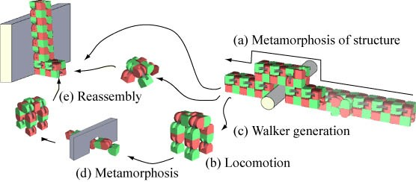

Fig 3.1:Transformation of modules

3.1.UNIQUE DESIGN
The design of Mbots has the advantages of both two types of modular robots, lattice type and chain (linear) type. This hybrid design, unique 3-D shape of the block parts, and parallel joint axes are all keys to realize a flexible self-reconfigurable robotic system.
An MBOT module is composed of two blocks (1/2 cubic & 1/2 cylindrical) and a link (Fig.1). Each of the three flat surfaces of each block can mechanically connect and couple with a surface of another module. All the connection surfaces have their gender and an active (male) surface can couple with a passive (female) surface (Fig. 1) in four possible relative orientations (Fig. 2). The connection is controlled by the module itself.
Lattice type feature:Each block rotates about its axis by the joint motor.If all the joint angles are either 0,90,180 degrees ,all the blocks align on the regular cubic lattice.Lattice structure is useful for self reconfiguration.
Chain type feature: When all the joint angles are controlled synchronously ,the whole body realizes a flexible robotic motion.
Each module has its own controller and intelligence, and all the controllers work cooperatively forming a Distributed Autonomous System as a whole.
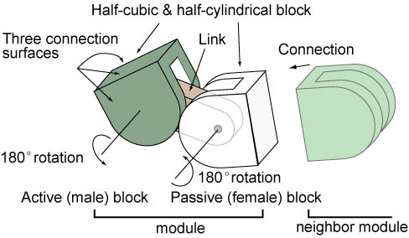
Fig 3.2:MBOTS module

CHAPTER 3

SOFTWARE IMPLEMENTATION

First of all, we need to design all the parts of the robot.For the designing purpose we use Fusion 360.The designed parts in Fusion 360 are then 3D printed. For this, ABS plastic is better because it is more machinable than others.As a prior step of assembling these 3D printable parts we used V-REP software for fast prototyping and verification.Using V-REP we can do the simulation of our model and can view whether our expected output can be met or not.

4.1.FUSION 360
FUSION 360 is the World's first cloud-based 3D CAD/CAM/CAE software which helps us to prepare for the future of design. It Connects entire product development process into one platform and enables real-time collaboration for engineers, designers, manufacturers, and product managers. It is a powerful software with advanced features for professional use.Images of the parts designed in Fusion 360 are listed below:
4.1.1.LIST OF 3D PRINTED PARTS

Fig 4.3:part 002 Fig 4.4:part 004
Fig 4.5:part 005 Fig 4.6:part 006

Fig 4.7:part 007 Fig 4.8:part 008
Fig 4.9:part 009 Fig 4.10:part 010

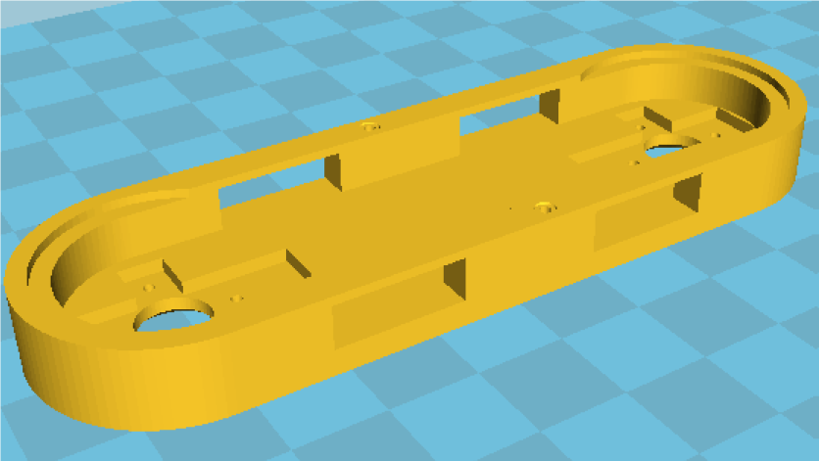
Fig 4.11:part 011 Fig 4.12:part 012

Fig 4.13:part 013 Fig 4.14:part 014

4.2.VREP
A robotics simulator is used to create application for a physical robot without depending on the actual machine, thus saving cost and time. In some case, these applications can be transferred onto the physical robot (or rebuilt) without modifications.The term robotics simulator can refer to several different robotics simulation applications. For example, in mobile robotics applications, behavior-based robotics simulators allow users to create simple worlds of rigid objects and light sources and to program robots to interact with these worlds. Behavior-based simulation allows for actions that are more biological in nature when compared to simulators that are more binary, or computational. In addition, behavior-based simulators may "learn" from mistakes and are capable of demonstrating the anthropomorphic quality of tenacity.One of the most popular applications for robotics simulators is for 3D modeling and rendering of a robot and its environment. This type of robotics software has a simulator that is a virtual robot, which is capable of emulating the motion of an actual robot in a real work envelope. Some robotics simulators use a physics engine for more realistic motion generation of the robot. The use of a robotics simulator for development of a robotics control program is highly recommended regardless of whether an actual robot is available or not. The simulator allows for robotics programs to be conveniently written and debugged off-line with the final version of the program tested on an actual robot. This primarily holds for industrial robotic applications only, since the success of off-line programming depends on how similar the real environment of the robot is to the simulated environment.Sensor-based robot actions are much more difficult to simulate and/or to program off-line, since the robot motion depends on the instantaneous sensor readings in the real world.
The robot simulator V-REP, with integrated development environment, is based on a distributed control architecture: each object/model can be individually controlled via an embedded script, a plugin, a ROS or BlueZero node, a remote API client, or a custom solution.This makes V-REP very versatile and ideal for multi-robot applications. Controllers can be written in C/C++, Python, Java, Lua, Matlab or Octave.V-REP is used for fast algorithm development, factory automation simulations, fast prototyping and verification, robotics related education, remote monitoring, safety double-checking, etc.

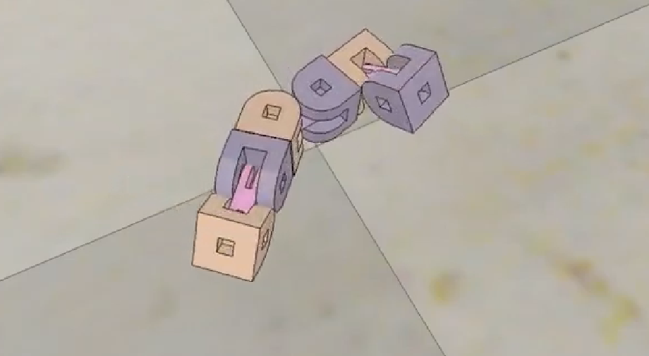
Fig 4.15:Snake motion
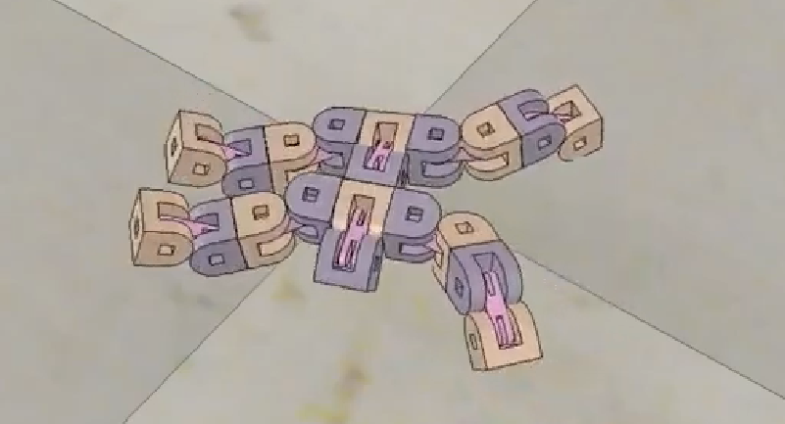

Fig 4.16:Hexapod motion

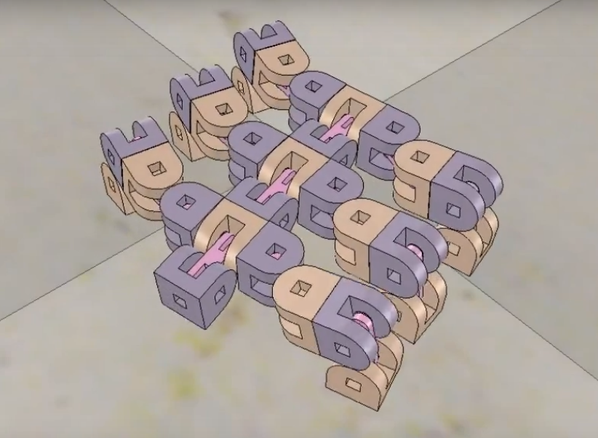

Fig 4.17:Quadrupted motion

CHAPTER 5

HARDWARE IMPLEMENTATION

Self reconfigurable robot systems composed of homogeneous and heterogeneous modules have an ability to configure their shapes and repair them by changing connecting relations between modules.When the robot is able to assemble its own body structure,it has “self assembly” function,and when it fixes itself by replacing defective part it has “self repair” function.These kinds of novel functions are expected to have various advantages for operations such as rescue,search,transportation and maintenance in unstructured environment.Most of the self reconfigurable robot systems can be classified by following features:
- Homogeneity/heterogeneity of module composition
- Dimension
- Connection method
- Communication and power supply method
- Local processor
- Centralized/distributed control
- Motion generation
The main features of our design is that they have got all the features below:
- Small and self contained robot
- Fully 3D printable
- Self reconfiguration capabilities
- Bluetooth and radio communication
- Multiple locomotion modes(snake,wheel,walker…)
- Rechargeable batteries
- Simulation model validated
- Cheap modules

5.1.SCHEMATICS AND COMPONENTS

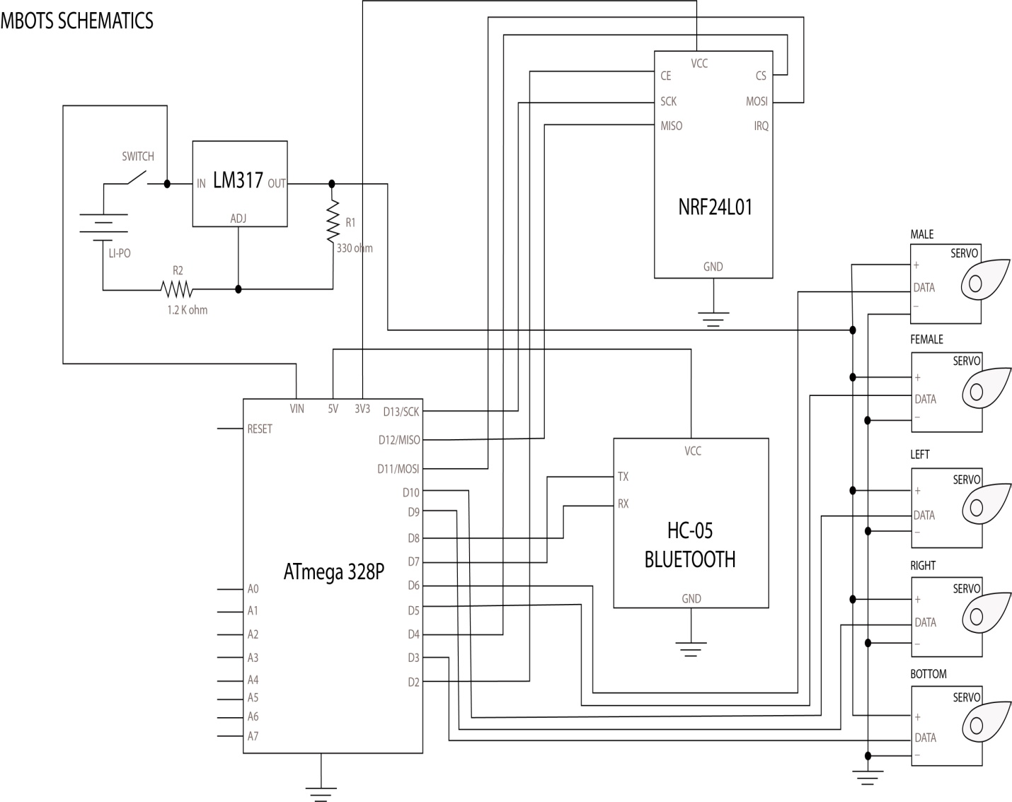
Fig 5.1:Schematic diagram

5.1.1.Atmega 328P
ATmega328 is a single chip microcontroller created by Atmel in the mega AVR family(later Microchip Technology acquired Atmel in 2016).It has a modified Harvard architecture 8 bit RISC processor core.The Atmel 8 bit AVR RISC based microcontroller combines 32KB ISP flash memory with read and write capabilities,1KB EEPROM ,2KB SRAM,23 general purpose I/O lines,32 general purpose working registers,three flexible timer/counters with compare modes,internal and external interrupts,serial programmable USART,a byte oriented 2 wire serial interface,SPI serial port,6 channel 10bit A/D converter (8 channels in TQFP and QFN/MLF packages),programmable watchdog timer with internal oscillator and five software selectable power savings modes.The device operates between 1.8-5.5 volts.The device achieves throughput approaching 1 MIPS per MHZ.

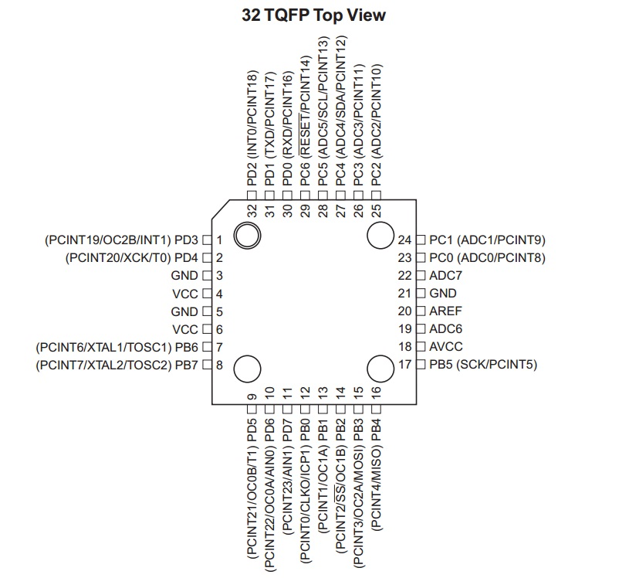
Fig 5.2:Pin diagram of ATMEGA328P

5.1.2.NRF24L01
nRF24L01 is a single-chip radio transceiver for the worldwide 2.4-2.5 GHz ISM band. The radio transmitters and receivers include frequency generator, enhanced Shock Burst mode controller, power amplifier, crystal oscillator modulator and demodulator. You can select the output power channel and protocol by setting through the SPI port. The current consumption for the nRF24L01+ is extremely low - under the transmitter mode, when the transmitting power is 0dBm, the current consumption is only 11.3mA; under the receiving mode, it is 13.5mA; under the power down and idle mode, the consumption is even lower. As for application, it's widely used in many devices such as wireless mouse and keyboard, game handle, remote control set, industry sensor,toys,etc
Features
1. nRF24L01+ is a single-chip radio transceiver for the worldwide 2.4-2.5 GHz ISM band, suitable for Arduino and Raspberry Pi.
2. Supports 6-channel receiving, with a transmission speed of up to 2Mbps.
3. Multi-frequency point: With 125 frequency points, it can meet multipoint communication and frequency hopping communication requirements.
4. Ultra-small: 24*15mm, with built-in 2.4GHz antenna.
5. Easy to develop: the link layer is fully integrated on the module, making it easy for development.
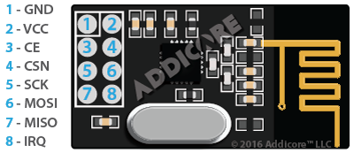
Fig 5.3:NRF24L01

5.1.3.HC-05 Bluetooth module
HC‐05 module is an easy to use Bluetooth SPP (Serial Port Protocol) module,designed for transparent wireless serial connection setup.The HC-05 Bluetooth Module can be used in a Master or Slave configuration, making it a great solution for wireless communication.This serial port bluetooth module is fully qualified Bluetooth V2.0+EDR (Enhanced Data Rate)3Mbps Modulation with complete 2.4GHz radio transceiver and baseband. It uses CSR Bluecore 04‐External single chip Rluetooth system with CMOS technology and with AFH (Adaptive Frequency Hopping Feature).The Bluetooth module HC-05 is a MASTER/SLAVE module.By default the factory setting is SLAVE.The Role of the module (Master or Slave) can be configured only by AT COMMANDS.The slave modules cannot initiate a connection to another Bluetooth device, but can accept connections.Master module can initiate a connection to other devices.The user can use it simply for a serial port replacement to establish connection between MCU and GPS, PC to your embedded project, etc.

Hardware Features
- Typical ‐80dBm sensitivity.
- Up to +4dBm RF transmit power.
- 3.3 to 5 V I/O.
- PIO(Programmable Input/Output) control.
- UART interface with programmable baud rate.
- With integrated antenna.
- With edge connector.

Software Features
- Slave default Baud rate: 9600, Data bits:8, Stop bit:1,Parity:No parity.
- Auto‐connect to the last device on power as default.
- Permit pairing device to connect as default.
- Auto‐pairing PINCODE:”1234” as default.

5.1.4.LM 317
The LM317 is a popular adjustable positive linear voltage regulator. It was designed by Robert C Dobkin in 1976 while he worked at National Semiconductor.The LM337 is the negative complement to the LM317, which regulates voltages below a reference. It was designed by Robert "Bob" Pease, who also worked for National Semiconductor.As linear regulators, the LM317 and LM337 are used in DC to DC converter applications.Linear regulators inherently waste power, the power dissipated is the current passed multiplied by the voltage difference between input and output. In use an LM317 commonly requires a heat sink to prevent the operating temperature rising too high. For large voltage differences, the energy lost as heat can ultimately be greater than that provided to the circuit. This is the trade-off for using linear regulators which are a simple way to provide a stable voltage with few additional components. The alternative is to use a switching voltage regulator which is usually more efficient but has a larger footprint and requires a larger number of associated components.In packages with a heat-dissipating mounting tab, such as TO-220, the tab is connected internally to the output pin which may make it necessary to electrically isolate the tab or the heat sink from other parts of the application circuit. Failure to do this may cause the circuit to short.
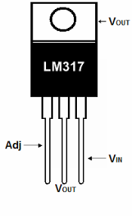
Fig 5.4:LM317

5.1.5. Servomotors

Fig 5.5:servomotor
A servomotor is a rotary actuator or linear actuator that allows for precise control of angular or linear position, velocity and acceleration. It consists of a suitable motor coupled to a sensor for position feedback. It also requires a relatively sophisticated controller, often a dedicated module designed specifically for use with servomotors.Servomotors are not a specific class of motor although the term servomotor is often used to refer to a motor suitable for use in a closed-loop control system.Servomotors are used in applications such as robotics, CNC machinery or automated manufacturing.A servomotor is a closed-loop servomechanism that uses position feedback to control its motion and final position. The input to its control is a signal (either analogue or digital) representing the position commanded for the output shaft.The motor is paired with some type of encoder to provide position and speed feedback. In the simplest case, only the position is measured. The measured position of the output is compared to the command position, the external input to the controller. If the output position differs from that required, an error signal is generated which then causes the motor to rotate in either direction, as needed to bring the output shaft to the appropriate position. As the positions approach, the error signal reduces to zero and the motor stops.The very simplest servomotors use position-only sensing via a potentiometer and bang-bang control of their motor; the motor always rotates at full speed (or is stopped). This type of servomotor is not widely used in industrial motion control, but it forms the basis of the simple and cheap servos used for radio-controlled models.More sophisticated servomotors use optical rotary encoders to measure the speed of the output shaft and a variable-speed drive to control the motor speed. Both of these enhancements, usually in combination with a PID control algorithm, allow the servomotor to be brought to its commanded position more quickly and more precisely, with less overshooting.

CHAPTER 6

ASSEMBLING OF PARTS
Assembly is the process of putting parts together. The aggregation of all processes by which various parts and subassemblies are built together to form a complete, geometrically designed assembly or product either by individual, batch or a continuous process. So in our proposed model the assembling is done as follows:
STEP 1
We need:
- 2 x Part 004-1
- 1 x Part 011-1
First of all, we have to ensure these 3 parts fit perfectly. It is very important that the 004-1 Parts rotate freely around the center. The easier they rotate, the less energy is lost in friction , the robot moves better.
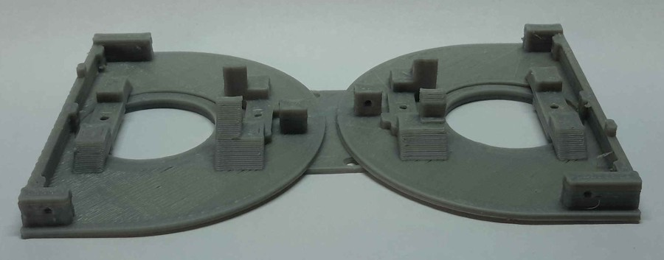
Fig 6.1:Step 1
STEP 2
We need:
- 2 x MG92B Servomotor
- 4 x 520 Ohms Resistor
The second thing to do is to adapt the MG92B Servomotors to turn the full 180 Degrees. The method we used was to add a couple resistors to each servo control circuit. Take apart the back cover of the servomotor (4 screws). Carefully separate the control circuit from the inside. The potentiometer is located under the circuit (it may be covered by a black film). Once you can access the 3 pins of the potentiometer,you have to unsolder the first and the third cable (not the center one). Then, you have to solder a 520Ohms resistor to each of these two pins, and then solder the cable to the resistor. Modify the servo to 180 degree. The control circuit does not fit the casing anymore, so we are going to stick it to the side of the metal case . Protect the circuit from short-circuits with some tape on both sides. Repeat the procedure for the other servomotor.
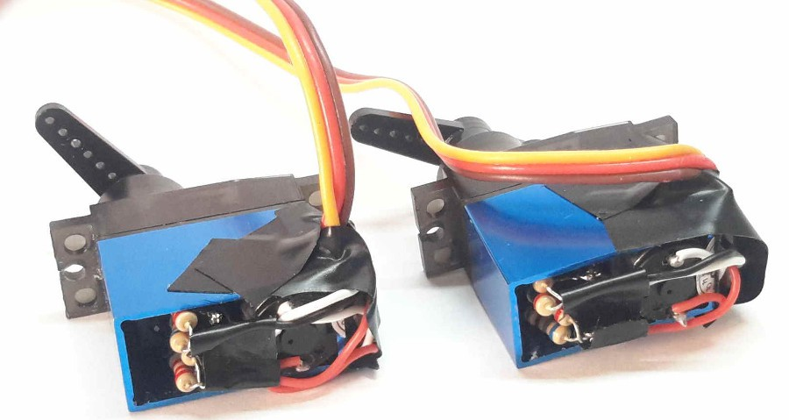
Fig 6.2 : Step 2
STEP 3
We need:
- 2 x Part 004-1
- 2 x MG92B Servomotors
In this step we are going to fix the motors to the printed parts. The motor should fit correctly. We can use the screws that come with the motor, but we will have to cut them to the right length.
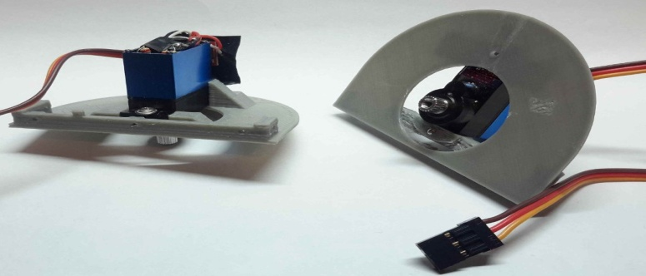
Fig 6.3 : Step 3
STEP 4
We need:
- 1 x Part 011-1
- 1 x Part 012-1
- 2 x Servo Arm (Cross)
Now we are going to fix the servo arms to the 3D printed part. This step is very important because we have to ensure that the servomotor is centered. If it is not centered, once assembled, the module motor won’t be able to rotate all the way.The next image illustrates the result. When the servo is set to 90º (servo.write(90)), the relative position of the parts should be like in the center picture. If the position is slightly deviated, like in the picture on the right, we will have to center the part.T his is a critical part, so be sure to get a well centered configuration. Once we get a well centered part, we have to be completely sure that we got a correct configuration. We can connect the two parts and test the rotation with the “sweep” example in arduino IDE.
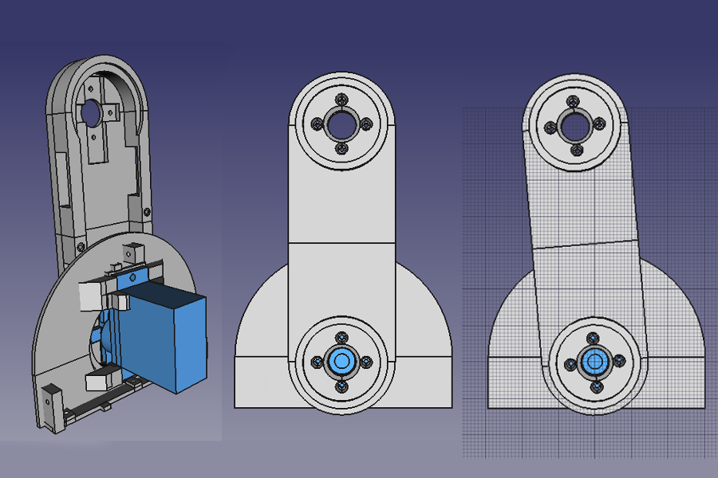
Fig 6.4 : Step 4

STEP 5
We need:
- 1 x Part 003-1

Now we will start to assembly the male half of the module. First of all we have to ensure that the hole in the part 003-1 fits with the previously assembled part 012-1. Once sanded, we can attach the part 003-1 to the part 004-1 using 3 screws.

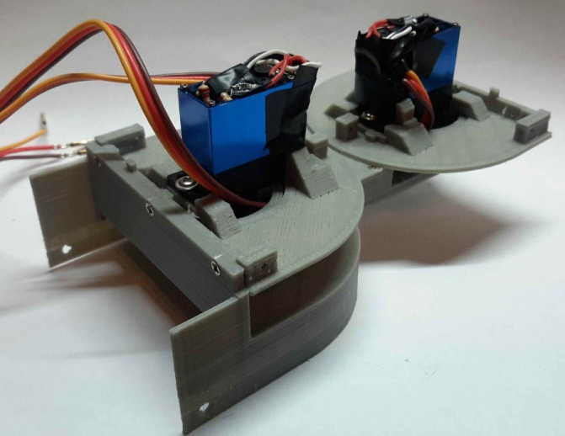
Fig 6.5 : Step 5
STEP 6
We need:
- 1 x Part 005-1
- 1 x Part 007-1
- 1 x Part 009-1
- 12 x Neodymium Magnets

In this step we will put the magnets on the male parts. It is very important to put all the magnets in the male part with the north pole facing the inside of the module. We put the magnets in the holes, and then we put a drop of glue sticking it to the part. For this procedure, we like to use hot melt glue.

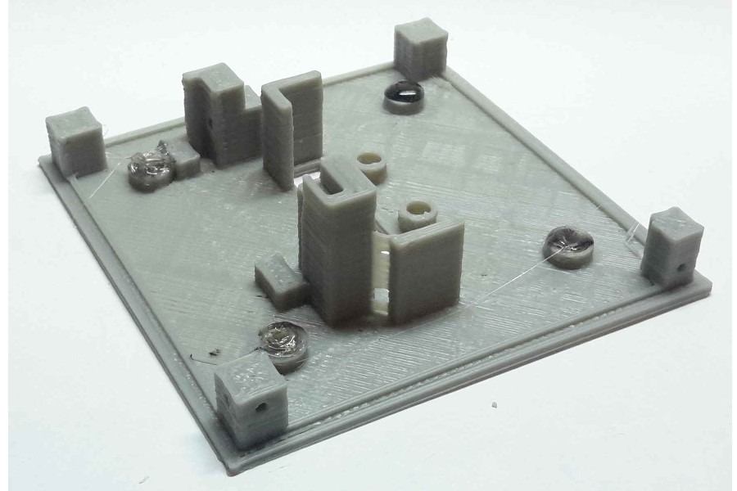
Fig 6.6 : Step 6A

We repeat the procedure for the 3 parts.

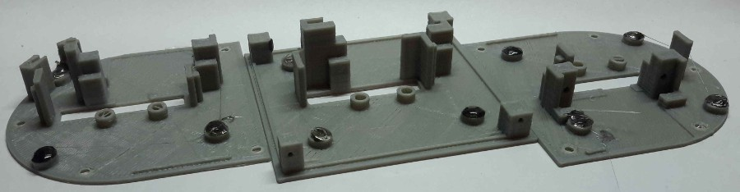
Fig 6.6 : Step 6B

STEP 7
We need:
- 1 x Part 006-1
- 1 x Part 008-1
- 1 x Part 010-1
- 12 x Neodymium Magnets
As we did in the previous step, we will put the magnets in the female parts. Now, remember to put all magnets with the north pole facing the outside of the module. If we do this correctly, the male parts won’t stick between them, but a male and a female part will be magnetically attracted.
STEP 8
We need:
- 3 x SG90 Servomotors
- 3 x Part 013-1
- 3 x Part 014-1
- 3 x Small Rubber Band (dental braces)
In this step we will prepare the coupling mechanism that holds the modules of the robot together. We first insert the servo arm (previosly cutted as in the pic) through the two printed parts. We have to ensure that these parts rotate freely around the servo arm. We put the servo in the 90º position (servo.write(90)), and then we screw the parts like in the picture, using the screw that came with the servo. Finally, we put the rubber band between the two parts. We repeat the procedure with the 2 SG90 servomotors left.

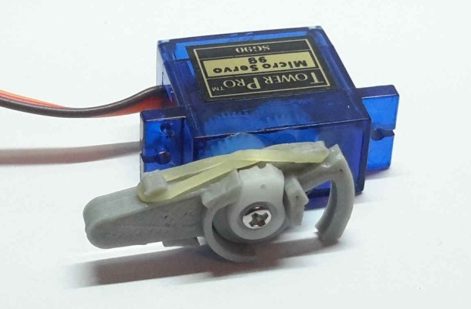
Fig 6.7 : Step 8
STEP 9
We need:
- 1 x Part 005-1 (step 6)
- 1 x Part 007-1 (step 6)
- 1 x Part 009-1 (step 6)
In this step we will fix the servos that form the coupling mechanism to the printed parts. First we will insert the servo in the correct position. Then, using the 2 screws that came with the servo, we will fix it to the part.
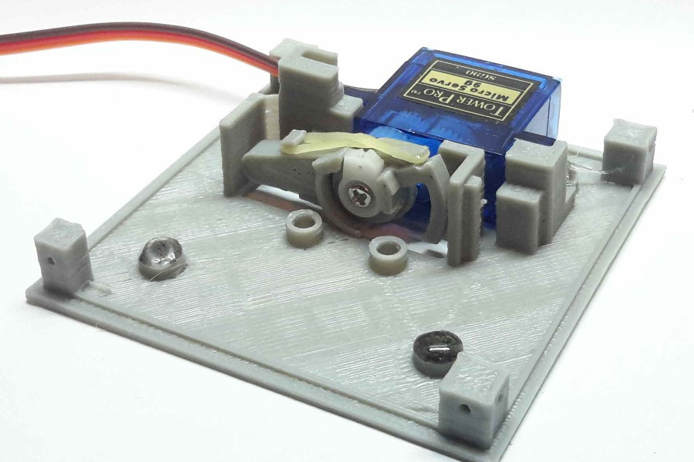
Fig 6.8 : Step 9
STEP 10
We need:
- 1 x HC-05 bluetooth module
- 1 x NRF24L01 radio module
In this step we will prepare the bluetooth and the radio module. We will have to remove the pin headers to solder wire directly, thus reducing the total volume of the modules. We will be using flat cable from an old PC, because we won’t have much space for cables.
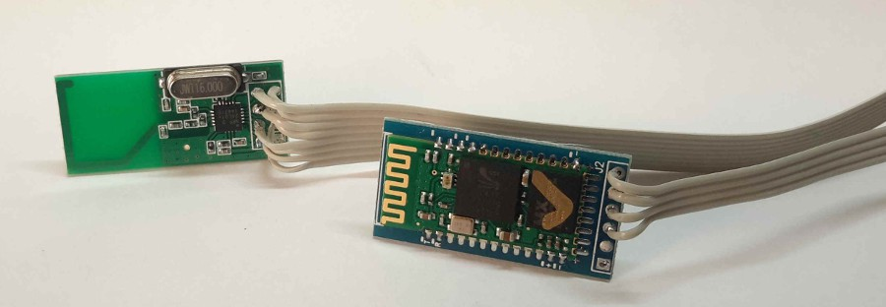
Fig 6.9 : Step 10

STEP 11
We need:
- 1 x NRF24L02 radio module (step 11)

Now we are going to stick the radio module to it’s final position. Due to the lack of space and the need to reduce weight, we decided to simple stick the module with some hot melt glue. We have to be sure that the module doesn’t make contact with the moving part in the center. The cables go to the other side of the module.

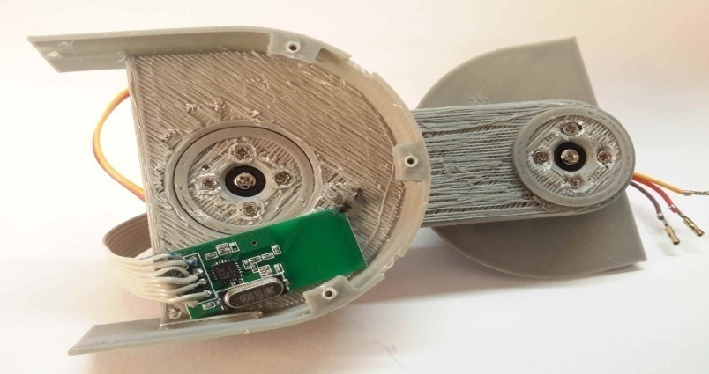
Fig 6.10 : Step 11
STEP 12
We need:
- 1 x Part 009-1
Using 3 screws, we mount the motor-equipped part 009-1 to the body of the module. Ensure that the servo cables don’t contact the coupling mechanism.

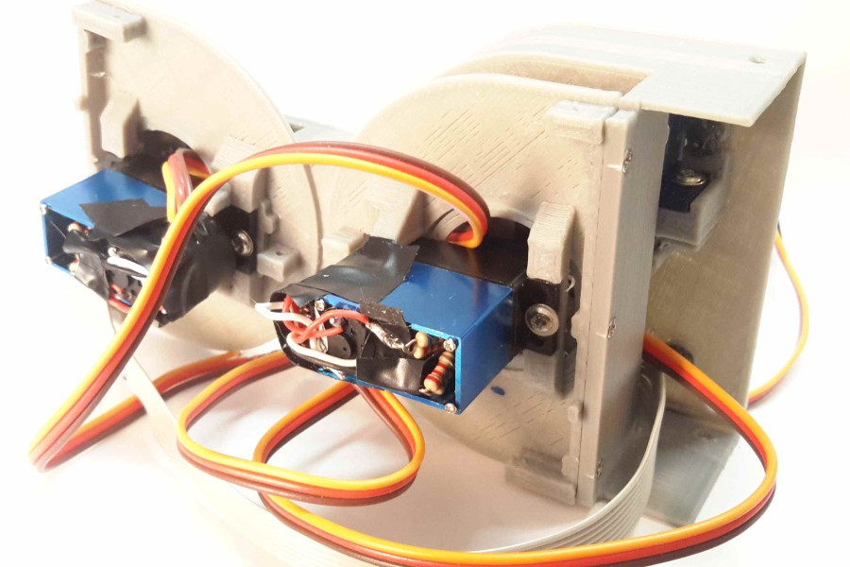
Fig 6.11 : Step 12

STEP 13
We need:
- 1 x Part 005-1

In this step we will mount the “base” of the robot, the part 005-1, with the previously mounted motor. Now it’s when we realize that the size of the cables connected to the radio module it’s very important, because they have to fit between the “base” servomotor and the top part. We need 4 screws for this step.

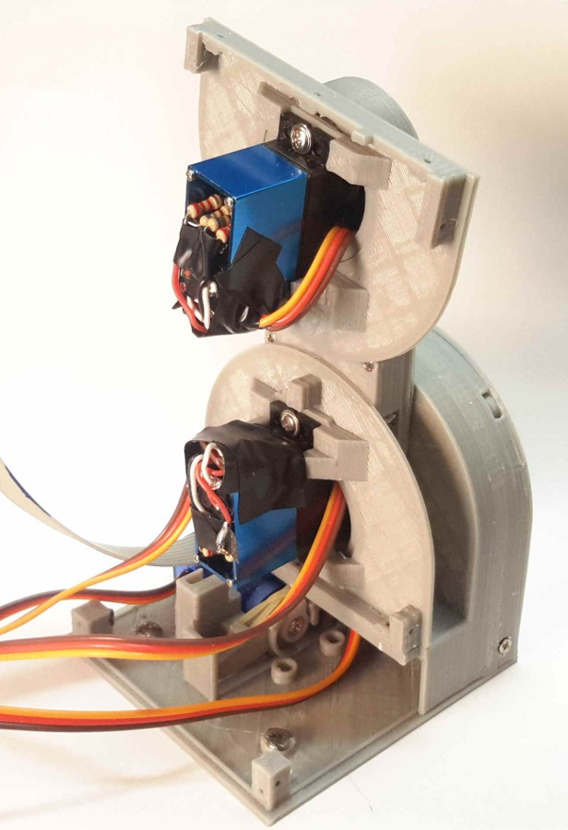
Fig 6.12 : Step 13
STEP 14
We need:
- 1 x LM317 Voltage Regulator
- 1 x 1200 Ohm Resistor
- 1 x 330 Ohm Resistor
Now we will configure our voltage regulator. Since we basically need the regulator for powering the servomotors, and since they can operate between 5 and 6 volts, we will set the regulator to the closer to 6 volts we can. We can use any other voltage regulator we want, considering the minimum current needs.The LM317 Voltage regulator allows us to adjust the output voltage using some resistors. You can find the details and the math in its datasheet, widely available. Refer to the datasheet to be sure of the connections. The resistors that we choose were 330 and 1200 Ohms, resulting 5.8 volts. We can also use 100 and 390 Ohms, resulting in 6.1 volts. Check the schematics.We need to power 5 servomotors with the output voltage from the regulator, so we need a small board to solder up the regulator, the resistors and the cables. The dimensions of the board shouldn’t exceed 1*2.2cm, and it should fit in the module as in the next pictures.
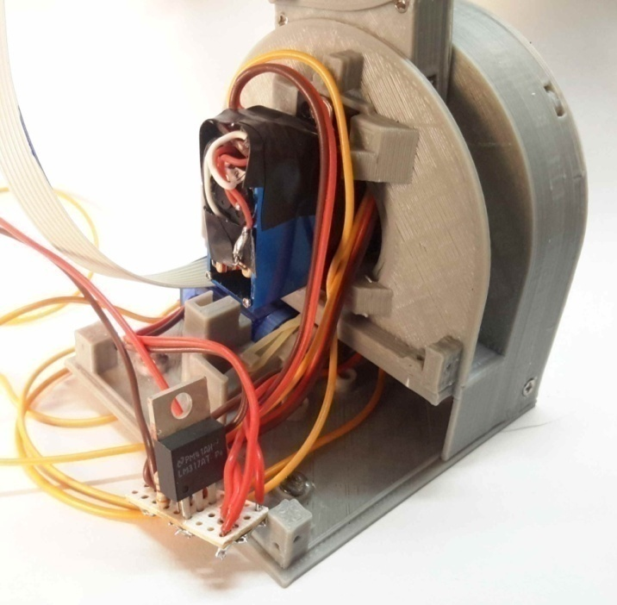
Fig 6.13 : Step 14
STEP 15
We need:
- 1 x Atmega 328p
The Atmega 328p microcontroller is the brain of our module, our robot. It is very important we test our uc before we proceed to do the following steps.In this step we will test the uc and the connection with the computer. Once tested, note that, in order to save some valuable space, we will need a pins-free board.
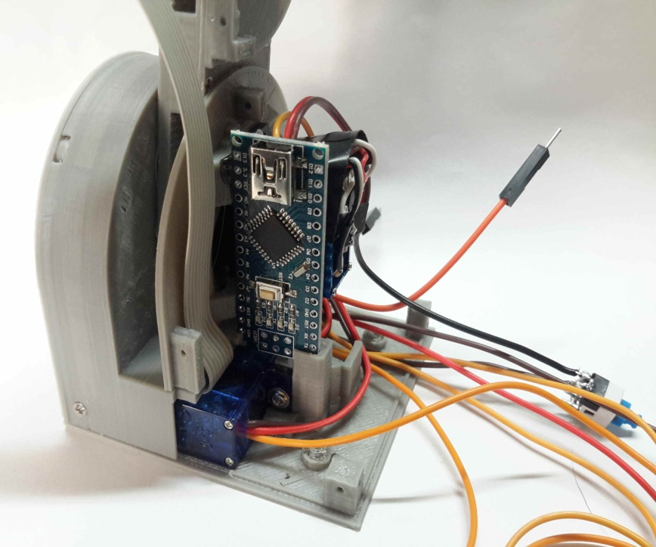
Fig 6.14 : Step 15
STEP 16
We need:
- 1 x HC-05 Bluetooth module
Now we are going to solder all the cables directly to the arduino. We will follow the schematics and we will try to keep the cables as short as possible. This is a tricky part, so you have to think how to put the cables to reduce length, to allow all the components to fit and to allow the coupling mechanisms to work. Check the schematics.
STEP 17
We need:
- 1 x Part 007-1
Now it’s time to fix the printed part to the module body, using 2 screws. As you can seen in the picture, the mini switch it’s just under the servo we just assembled. We have to stick the mini switch in a position that, when pressed, it doesn’t protrude from the module.

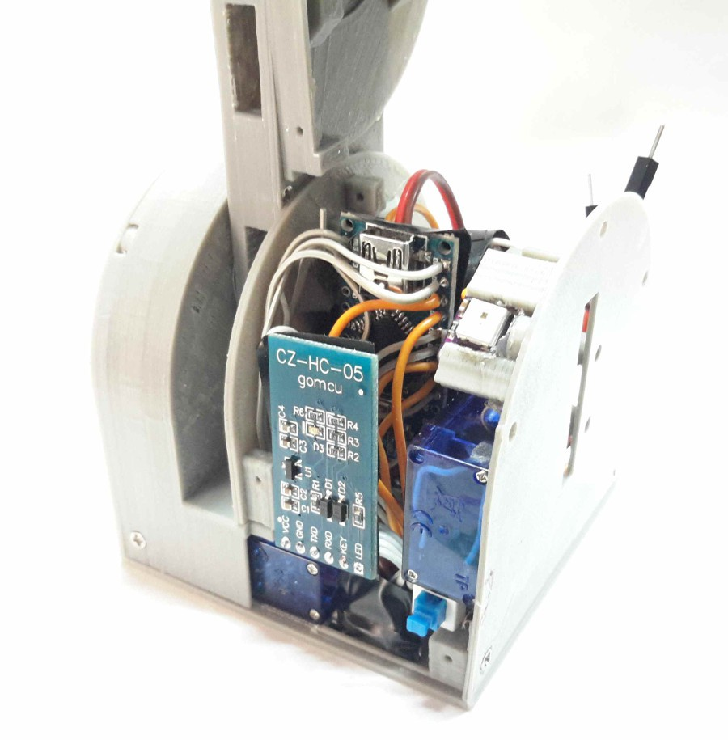
Fig 6.15 : Step 17
STEP 18
We need:
- 1 x Part 003-1
- 1 x Part 006-1
- 1 x Part 008-1
- 1 x Part 010-1
- 2 x Li-Po Batteries
Just as we did in step 6, we are going to assemble the part 003-1 to the other half of the module. We have to make sure that it rotates nice and easy.
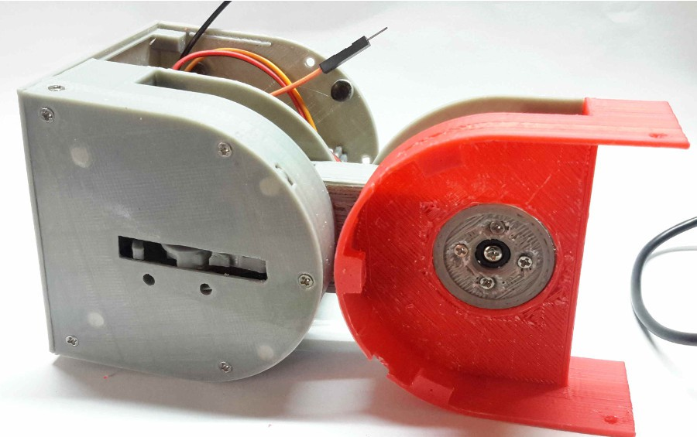
Fig 6.16 : Step 18
Now that we have the module almost assembled, we have to think where do we want to put the batteries. The module is designed to host the batteries in the male part, at the back of the arduino, but since we are not using the empty space in the female part, we are going to put the batteries in the female half. This way we get a better weight distribution.

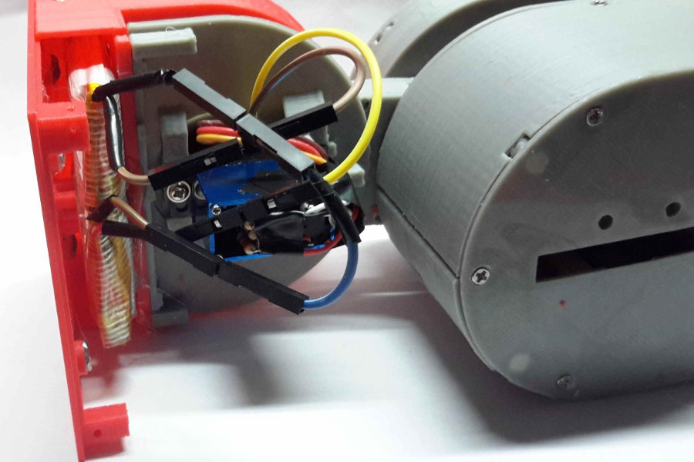
Fig 6.17 : Step 18
STEP 19
We need:
- 2 x Part 001-1
- 2 x Part 002-1

This is the final step! We are going to assemble the last parts. First of all, we are going to test if they fit correctly. If not, we have to sand until we get them to fit nicely.

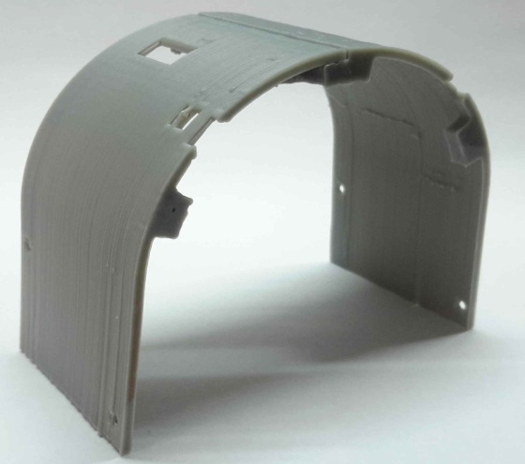
Fig 6.18 : Step 19A

And this is the final result.
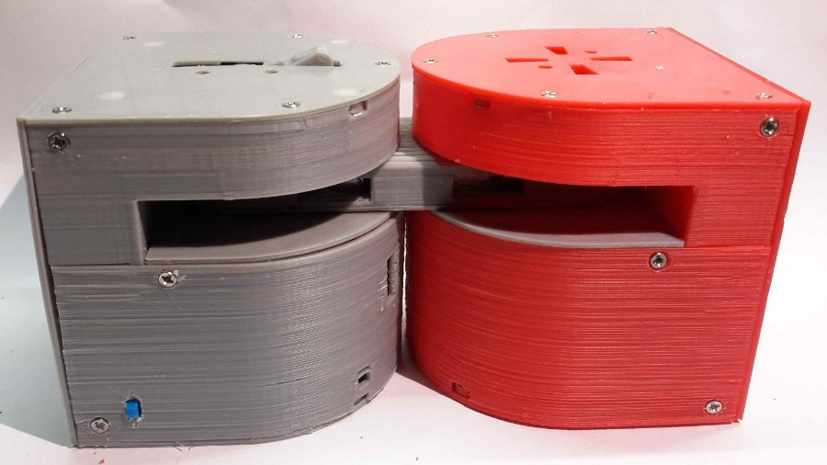
Fig 6.19 : Step 19B
Now we just have to program the Arduino with the available code.

CHAPTER 7

CONCLUSION AND FUTURESCOPE

The Dtto Robot is a modular transformable robot designed to be versatile, flexible and self-reconfigurable. The idea of modular robots is that they can adopt any shape they want, by changing the position and the connection of their modules. The mechanism was able to hold the modules together, but also separate them when needed.The small size, the versatility and the limitless shapes it can adopt, make Dtto the perfect robot for all kind of search and rescue operations. Here we have described the hardware of the module,softwares required,simulator required for motion and the experimental results using developed modules.
While looking for the minimum size, the robot is designed to contain almost all the electronics and motors in one half, so that there is a large free space in the other half.As in future we plan to use that free space to install a thermal camera, microphone and speakers, multiple sensors, more actuators (like grippers) or even more batteries.

REFERENCE

- Simulation Study of Snake-like Robot’s Serpentine Locomotion Based on Recurdyn; by Wang Nan, Pang Bo and Zhou Sha-Sha
- Modular Self-Reconfigurable Robot Systems: Challenges and Opportunities for the Future, by Yim, Shen, Salemi, Rus, Moll, Lipson, Klavins & Chirikjian, published in IEEE Robotics & Automation Magazine March 2007
- Self-Reconfigurable Robot: Shape-Changing Cellular Robots Can Exceed Conventional Robot Flexibility, by Murata & Kurokawa, published in IEEE Robotics & Automation Magazine March 2007
- Center-configuration selection technique for the reconfigurable modular robot.By Liu JG, Wang YC, et al., published in Science in China Series F: Information Sciences 2007.
- Self Reconfiguring Modular Robotics Essentials, Popular science Introduction to SRCMR fundamentals and some of the profound consequences it will have. By Per Sjöborg 2009.

